CONCURRENCY IN JAVA
Threads in general
Threads can be created in 2 main ways:
- Thread class extension
- Runnable interface inclusion
The “main” method of a thread is run. The differences between these methods are: class extension remove the possibility to extend other classes but it provide some methods that runnable doesn’t have. Runnable allow to have an object that you can share among multiple threads.
A thread has a stack and registers.
States of a thread
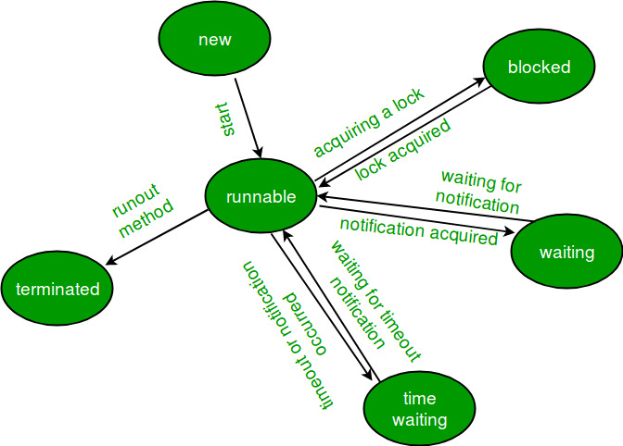
A multi-threaded program allocates a fixed amount of time to each individual thread. Each and every thread runs for a short while and then pauses and relinquishes the CPU to another thread so that other threads can get a chance to run. When this happens, all such threads that are ready to run, waiting for the CPU and the currently running thread lie in a runnable state.
Using the method getState is possible to read the thread’s state.
A thread can be started using start() method, put in wait state with sleep() and wait until his end with join(), it put the currentThread into a waiting state until the thread, on which the call is performed, has finished.
Concepts:

Mutual Exclusion: It means that only one thread or process can execute a block of code (critical section) at a time.
Visibility: It means that changes made by one thread to shared data are visible to other threads

Synchronization
In multi-thread programs is common to have threads that share a resource, and the can read and write simultaneously on it. This can cause errors and inconsistency problems. The solution of the problem is synchronization!
There are different ways to synchronize data in Java.
- Synchronize block or methods: that lock the code portion and only once thread can access to that zone, the others must wait.
Java’s synchronized keyword guarantees both mutual exclusion and visibility.
  - ADVANTAGES:
    - Mutual exclusion
    - instances and statics methods can execute concurrently because they are used to lock different objects
  - DISADVANTAGE:
    - Concurrency Limitations: Java synchronization does not allow concurrent reads.
    - Decreases Efficiency: Java synchronized method run very slowly and can degrade the performance, so you should synchronize the method when it is absolutely necessary otherwise not and to synchronize block only for critical section of the code.
- Explicit lock: RetrentantLock is a class that allows locking of code portion an also unlock of it, there is a variant that allows read simultaneously and write lock for only one thread. It called ReadWriterRentantLock it gives good performance because it not lock resource for reading.
Thread safety

Volatile keyword
A volatile keyword is a field modifier that ensures that the object can be used by multiple threads at the same time without having any problem. volatile is one good way of ensuring that the Java program is thread-safe. a volatile keyword can be used as an alternative way of achieving Thread Safety in Java.
Volatile variables have the visibility features of synchronized but not the atomicity features. The values of the volatile variable will never be cached and all writes and reads will be done to and from the main memory.

Atomic Variable
Using an atomic variable is another way to achieve thread-safety in java. When variables are shared by multiple threads, the atomic variable ensures that threads don’t crash into each other.
An atomic variable ensure consistence of data.
multi-threaded environment is concerned, it may lead to inconsistent results. It happens because updating “var” is done in three steps: Reading, updating, and writing. If two or more threads try to update the value at the same time, then it may not update properly. We could use synchronization

CAS
cas is a idiom used to verify integrity of data.
It called Compare And Set, so this means that function compare old value(previous value) with the new once(expected) and if comparison is is true
it return true. To use an optimistic approach without suspend thread and have a lot of context-switch we could use the following pattern when we work with CAS method. A do-while, inside it we assign values and in the while condition we put the CAS method.
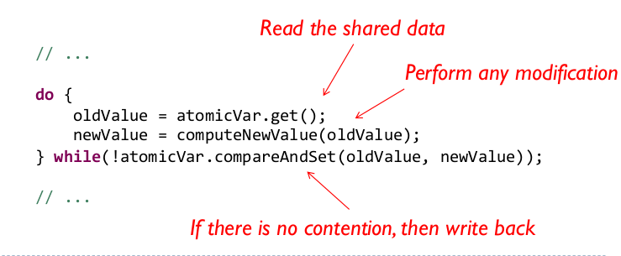

Synchronization methods in Java (Summary)
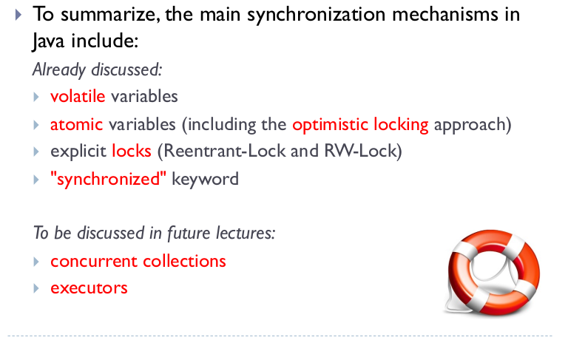

Race condition
Definition:
A race-condition is present when a program reads the value of a variable/field and needs then to perform an operation that depends on that value (e.g. check-then-act or read-modify-write).

Check then act: it’s a problem that concern decision instructions, they took decisions based on possibly old values, example if condition.
Read modify write: it’s a problem that concern edit instructions, it updated date based on not updated data, example var++

Compound actions: they are sequences of instructions that must be execute atomically to maintain the integrity, so be thread-safe.

Concurrency and OOP
To manage the objects in concurrent programming we must be aware about object creation and modify.
It is located on the heap memory, and therefore every thread that has address can access to it, sensitive zone.
This could generate inconsistency.
To avoid inconsistency we must create classes Immutable, thus objects can’t be modified, the methods that edit data will return new object’s instance.

Mutable objects must be synchronized, so they must have lock in the methods or in the implementation we must put that to protect the object.

We must publish an object, it means that: making it accessible to the code outside the scope of the class (or the method, in case of local variables), that owns it in a specific moment.

Safe publication of an object means that the reference to the object and its state are made accessible simultaneously (in an atomic way) => this can only be done by using synchronization tools. Visibility problems must be avoided!

Ways to create safely objects:
A safely constructed object can be safely published:
- by initializing a static reference with default initialization or a static initializer
(public static MyObject obj = new MyObject(42);)
- by storing the object reference in a volatile variable (or in an AtomicReference)
- by storing the object reference in a final field of a safely-constructed
object
- by storing the object reference in a lock-protected field
- by storing the object reference in a thread-safe collection

A safely published object can be accessed in a read-only form without synchronization, even if the object is not immutable. In this case, we are talking about effectively immutable objects.

